Participate in co-ed track relays & field events of all ages and abilities!
Showcase your energy and talents in a
challenging, competitive, and fun environment!
Experience teambuilding and camaraderie like never before!
Participate in an Enron tradition since 1994!
Track Events
Field Events
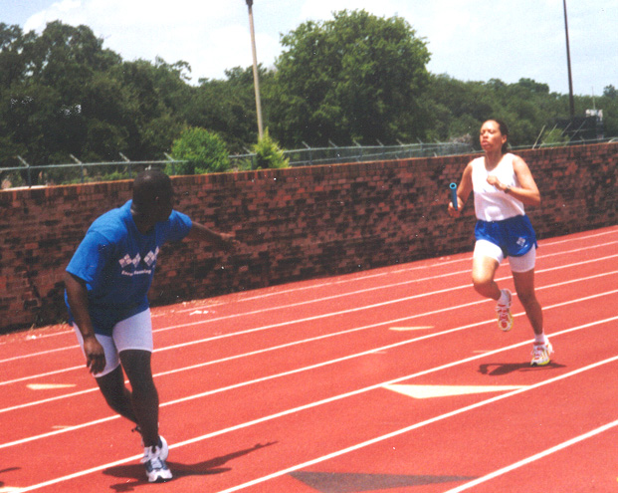
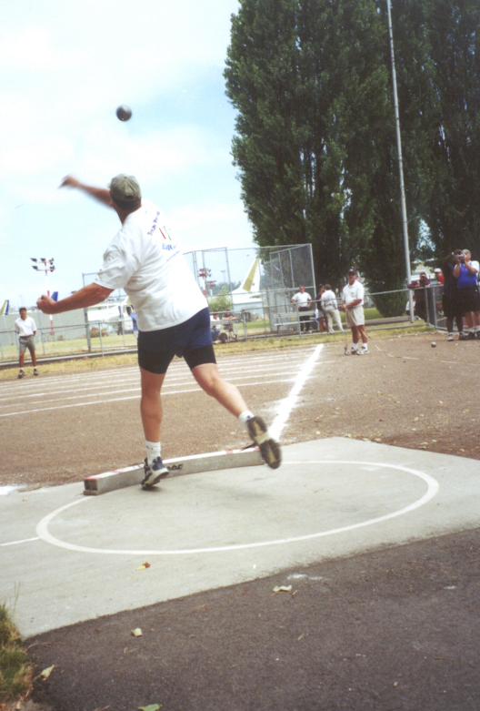
Shotput
Discus
Javelin
High Jump
Long Jump
3K Team Race
Men’s Mile Team Race
800 Meter Team Race

Sprint Relays
Distance Relays
You’re just what we’re looking for to participate in the Regional Track & Field Meet June 9th!
We’re looking to field 3 Enron Teams, that’s 120 athletes! There is a spot for everyone whether you want to compete for the Gold or just get a feel for track & field and have a good time!

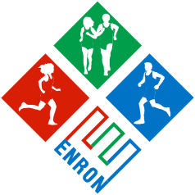

USCAA National Track & Field

Championships
July 21-22, 2001
Renton, WA

"100 Meters to 100 Miles"
USCAA Regional Track & Field

Championships
June 9, 2001
Rice University Track
Please complete the following and return to Cindy Richardson via e-mail ASAP.

Name | Date of Birth | Employee/Contractor Since | Extension

I AM interested in the 2001 Enron Track & Field program. Please see my interests below.

I AM NOT interested in the 2001 Enron Track & Field program at this time.

I know of someone who may be interested, please contact at extension .

TRACK EVENTS |  |  | FIELD EVENTS
Events of Interest | Estimated/Latest Time | Date | Events of Interest | Estimated/Latest Distance/Height | Date
100m |  |  | Shotput
200m |  |  | Discus
400m |  |  | Javelin
800m |  |  | High Jump
1600m |  |  | Long Jump
3000m |  |  | Other

Sprint to: http://home.enron.com:84/erc/index.html for more information.

